Don’t burn off your silage potential

Certain silages can start heating after opening the silo, a phenomenon known as aerobic instability. Not only can this pose problems for cattle eating behavior, but every calorie lost in heat is a calorie lost for milk production. Why do certain silages heat and others don’t? Silage making practices, as well as the nature of the crop, are part of the answer, but not the only part. Feedout management and the use of silage inoculants can also help control losses of dry matter (DM) due to heat.
Why are silages heating?
“In nature nothing is created, nothing is lost, everything changes.” Lavoisier’s rule also applies to forage. The calories released by a heating silo come from the degradation of nutrients by spoilage microorganisms, essentially undesired yeasts and molds. During the first phase of ensiling, or front-end fermentation, oxygen is consumed by lactic acid bacteria (LAB) and the forage is acidified under the action of LAB, which inhibit the development and activity of spoilage yeasts and molds. These microbes are maintained in a dormant phase but not killed. At feedout, the silage is exposed to oxygen and these microorganisms become active again, degrading the forage and releasing heat. The temperature of the silage rises as the air penetrates into the face. This is known as silage aerobic instability. Aerobically unstable silage can continue to heat in the feedbunk and cause the total mixed ration (TMR) to heat too. Aerobic stability is an important characteristic to describe silage quality. It is defined as: “The amount of time a silage remains stable (and does not spoil) after it is exposed to air under defined conditions.”
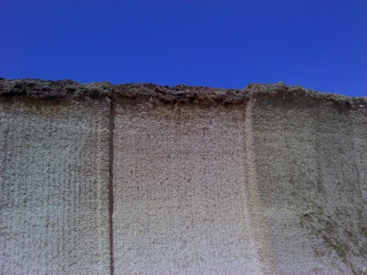
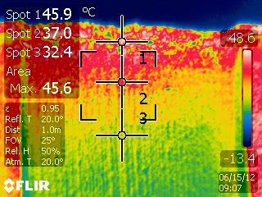
How much hot is too hot?
Silage heating is linked to several variables, in particular the compaction of the silo. The denser the silo, the less air is entrapped. This allows fewer spoilage organisms to grow and reduces the distance air can penetrate into the silage face. Air can penetrate over one meter into the face of a bunker depending on the packing density. Heating is also variable across the face of the silo. The density of the silage is always lower at the top, which allows the air to penetrate further. Here, the spoilage organisms tend to be more active, generating more heat. Moving down the face, the density increases and the face becomes cooler. Figure 1 shows an infrared picture of a silo face (right). In this example, the top of the silo face is hotter by 13.5°C as compared to the main body of the silo and 25.9°C hotter than the ambient temperature. In fact, there is no temperature at which silage can be considered as “heating.” It is the difference in the temperature from the bottom to the top of the silage face that matters. A difference in temperature greater than 3°C shows the silage to be heating. A difference greater than 20°C is a very serious heating issue.
Figure 1: Silage heating at feedout. The infrared picture on the right corresponds to the silo face on the left. Temperature from top to bottom (circles 1, 2, 3), are 45.9, 37 and 32.4°C (ambient temperature 20° C).
What are the consequences on my silage?
The first immediate consequence of aerobic instability is the loss of dry matter (DM) content. When producing heat, microorganisms are literally eating away silage nutrients and milk energy is converted into heat before reaching the feedbunk. It is estimated that up to 50% of DM losses in silage are due to aerobic instability. In addition, heating silage loses palatability and can reduce feed intake.
Heat generated in aerobically unstable silage can be converted to lost milk production and reduced revenue. Assuming a 1,000 tonne maize clamp at 30% DM, the loss of milk associated to silage heating represents:
Ambient Temperature | Clamp Temperature | Lost Milk
20°C | 25°C | 2,930 Litres
20°C | 30°C | 5,860 Litres
20°C | 35°C | 8,790 Litres
20°C | 40°C | 11,720 Litres
20°C | 45°C | 14,650 Litres
Table 1: Estimated milk lost associated to silage aerobic instability (based on the assumption that 10°C rise in temperature of 1 tonne silage over a 24hr period is equivalent to 30MCal in lost energy, which is the energy required to produce 5l of milk (Private communication from USDA).

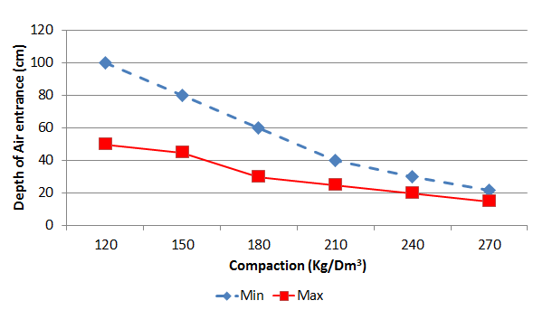
Silage heating can cost a lot in lost milk potential. Not all silos are equal with regard to heating and some silage is more prone to heating, such as high DM content, more difficult to compact silages, etc.
How to control heating in silage?
Several strategies can help control heat formation, through good ensiling and good feedout management, at both ends of the silo life cycle.
At ensiling. As seen previously, the denser the silage, the less air can penetrate into the silo face at feedout. It is important to ensure good ensiling practices and focus on packing density. Figure 2 shows the relationship between silo density and the depth air can penetrate into the silo face. Usually, optimal density is considered around 240kg DM/m³.
Figure 2: Relationship between air penetration in the silo face and silo packing density (Losand, 2003).
Silages with high DM or long chop length are more difficult to pack and usually linked to aerobic instability issues. The use of an adapted silage inoculant, designed to both aid in fermentation (presence of LAB) and reduce heating thanks to anti-fungal and/or anti-mold action, is recommended in these cases. Scientific and field trials conducted with Sil-All Fireguard, a hybrid inoculant containing a unique combination of LAB, enzymes and fungal inhibitors, show its efficacy to improve the aerobic stability of difficult forages (Figure 3).
Figure 3: Maize aerobic stability at feedout at 49 and 90 days after ensiling. (Trial: Landwirtschaftskammer Schleswig Holstein Prof Thayssen, 2014).
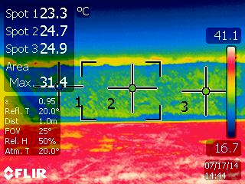
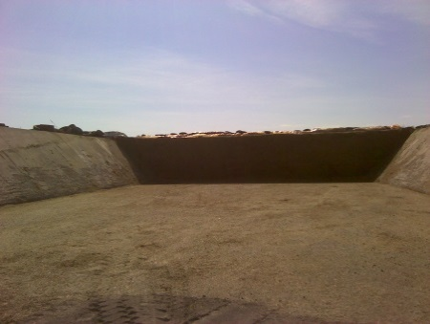
At feedout. If the face is disturbed in a manner that will allow air to penetrate (i. e. through feeding with a grab or using a bucket), the undesirable yeast behind the face will become active again as air penetrates into the silage and initiates yeast growth. This will result in silage heating. This process is remarkably rapid, happening within hours, sometimes less than one hour. Feedout rates are defined by the width and height of the bunker/pile and also by the number of animals being fed. The rate of silage feedout is often the Achilles heel of the farm. If the face of the silage is at a low density because of poor compaction or inappropriate feedout, the face must be crossed by anywhere between 45 and 85cm every day in order to stay ‘ahead’ of the oxygen seeping into the silage. In contrast, if the silage is well compacted and the compaction is maintained through feedout, for example at 240KgDM/m³, a feedout rate between 20-30cm/day allows to stay ahead of the heating.
Figure 4: Stable silage. The infrared picture on the right corresponds to the silo front on the left. Temperature from top to bottom (circles 1, 2, 3), are 23.3, 24.7 and 24.9°C respectively (ambient temperature 20° C)

The silage pictured on Figure 4 is stable and not showing any heating. The speed of fermentation and good compaction of the silage at time of ensiling, coupled with the good management of the silage at feedout has maintained the silage density and stopped air penetrating into and behind the face of the silage and prevented molds and yeast from developing.

In conclusion, control of the stability of the silage is partly due to the rate of the fermentation, partly due to the feedout management of the silage and partly due to the rate of feedout/speed of crossing the face. All aspects are equally important to controlling the feed value of the silage and none must be ignored.

For more information, please contact enquiries@sil-all.com

